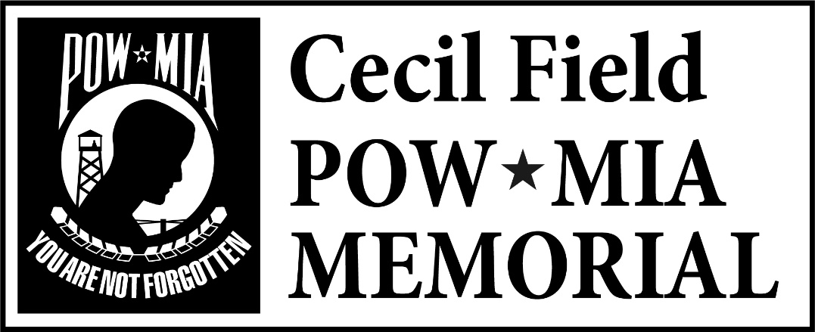

At the Cecil Field POW/MIA Memorial, Inc. Board of Directors meeting
29 November 2017, I _________________ Director, by my signature below acknowledge receipt of following:

- Bylaws of Cecil Field POW/MIA Memorial, Inc. dated 15 November 2017.
- Cecil Field POW/MIA Memorial, Inc. Conflict of Interest Policy dated 15 November 2017.
- Cecil Field POW/MIA Memorial, Inc. Code of Ethics and Whistleblower Policy dated 15 November 2017.
- Cecil Field POW/MIA Memorial, Inc. Document Retention Policy dated 15 November 2017.
- Cecil Field POW/MIA Memorial, Inc. Financial Policy and Procedural Manual, Dated 15 November 2017

________________________________________ __________________
Signature Date

